**Factibilidad de un modelo productivo forestal en áreas agrícolas marginales del Centro de la Provincia de Santa Fe, Argentina.**

**Forest productive model feasibility in marginal agricultural areas of the Center of the Province of Santa Fe, Argentina.**

**Abstract**

In order to expand forestry in the Center of Santa Fe Province, Argentina, a field trial was carried out on a 5-hectare property, using different genetic materials of Eucalyptus. Productive variables were evaluated and the financial and economic viability of the forest production model in marginal agricultural areas was studied. It was found that the GC08 genetic material presented the best initial growth, followed by the GC09 clone, while the GCH105 clone showed lower growth. The GTH117 clone presented the lowest growth rates but still below expectations. E. dunnii seed material had slower initial growth compared to clonal materials. Soil management was key to the success of the plantation in the early years. It was concluded that the forestry biobusiness model is viable in economic and financial terms, and the importance of the circularity of the economy and the inclusion of afforestation to generate social and environmental value are highlighted.

**Keywords:** forest bioeconomy, bioenergy, financial viability, diversification.

**Resumen**

Con el objetivo de expandir la actividad forestal en el Centro de la Provincia de Santa Fe, Argentina, se realizó un ensayo a campo en un predio de 5 hectáreas, utilizando diferentes materiales genéticos de Eucalyptus. Se evaluaron variables productivas y se estudió la viabilidad financiera y económica del modelo productivo forestal en áreas agrícolas marginales. Se encontró que el material genético GC08 presentó el mejor crecimiento inicial, seguido por el clon GC09, mientras que el clon GCH105 mostró un crecimiento menor. El clon GTH117 presentó las tasas de crecimiento más bajas, pero aún por debajo de las expectativas. El material de semilla de E. dunnii tuvo un crecimiento inicial más lento en comparación con los materiales clonales. El manejo del suelo resultó clave para el éxito de la plantación en los primeros años. Se concluyó que el modelo de bionegocio forestal es viable en términos económicos y financieros, y se resalta la importancia de la circularidad de la economía y la inclusión de las forestaciones para generar valor social y ambiental.

Palabras claves: bioeconomía forestal, bioenergía, viabilidad económico-financiera, diversificación.

**Introduction**

Afforestation is an essential resource in Argentina, contributing to the well-being and improvement of the quality of life of the population. It has a positive impact on global climate change mitigation through its role in climate regulation, biodiversity, protection of water basins, soil conservation, water provision, ecosystem maintenance, and carbon capture. Its importance at a productive, social, and environmental level is strategic (IICA, 2021).

In Argentina, biomass of forest origin is an interesting alternative for replacing non-renewable energies, considering that the country's energy matrix is dominated by fossil fuels, with two particular characteristics: the high contribution of natural gas (53%) and petroleum (33%) and the very low participation of coal. This configuration makes the energy sector the main emitter of greenhouse gases and raises questions about the country's energy security (ILO, 2019).

On the other hand, it serves as a raw material for various industries such as timber, food, chemical, paper, among others (Araujo Vieira de Souza & Bender, 2020; Candiotti, 2014).

The cultivation of forest species also reduces the pressure of native forest exploitation, thus favoring the reduction of deforestation rates in natural areas and the recovery of degraded soils (AfoA, 2012; Araujo Vieira de Souza & Bender, 2020; PACN, 2020).

The province of Santa Fe has favorable conditions for forest production. It has around 40% of halomorphic soils, unproductive for conventional crops in the region (INTA 1991), which could be used for forest production. Additionally, it has laws that facilitate the decision of their use such as the National Forestry Promotion Law 25.080 (Candiotti, 2014; MAGyP, 2020; Misirlian, 2019).

The objective of this work is to analyze the performance of five genetic materials of Eucalyptus sp. under different soil management practices and, based on these results, evaluate the financial and economic feasibility of a productive model formed by the materials with the best productive response in marginal soils.

**Materials and Methods**

To conduct the analysis of the performance of different genetic materials under various cultural practices adaptable to soils with limitations such as saline, sodic, compacted, flooded, and low fertility, a trial was carried out on a 5-hectare plot located in the town of San Agustín, province of Santa Fe, Argentina, belonging to the Cooperativa Guillermo Lehmann. The land has two heterogeneous zones due to its soil conditions. The zone with better suitability is well to moderately drained. It is a relatively deep soil with slight limitations in the developed profiles, reducing permeability. The second zone corresponds to a deep, moderately drained soil, developed in sectors of extended plains. The slightly impeded drainage condition represents its most serious and frequent limitation.

The trial was conducted with genetic materials corresponding to the genus Eucalyptus. Its particularity is that it adapts to virtually all climates (except extremely cold ones), can produce large quantities of wood in relatively short periods of time, has the ability to recover from negative events (fire, frost, drought, pests, browsing, among others), adapts to poor and deteriorated soils, and can be used for various purposes (cellulose pulp, timber, firewood, poles, etc.). The eucalyptus genetic materials used were:

* Three clones of E. grandis x E. camaldulensis hybrids: the crossing between E. camaldulensis, which contributes ruggedness, wood density, and frost tolerance, and E. grandis, which provides productivity and good stem form. The materials are: GCH105 (CIEF - Paul Forestal SRL); GC08 (INTA); and GC09 (INTA).
* One clone of GTH117 hybrid: from E. tereticornis (which is very similar to E. camaldulensis, with better growth conditions and forest form, but less plasticity) x E. grandis: E. grandis x E. tereticornis CIEF - Paul Forestal SRL.
* A material of E. dunnii Clonal Seedling Orchard (HSC) INTA - Castelar, which is one of the alternative species to E. grandis because it is more frost-tolerant and is recommended for its productive versatility (good suitability for sawn timber, bioenergy, and cellulose) and greater tolerance to pests such as the Eucalyptus gall wasp (Leptocybe invasa) and Eucalyptus psyllid (Glycaspis brimblecombei).

The trial was arranged in a completely randomized block design, in split plots, with four blocks. Within each block, the five genetic materials were planted, representing the main plots. Each plot was divided into subplots to apply the management practices: with subsoil plowing at 60 cm plus fertilization, and without subsoil plowing or fertilization. Fertilization was carried out at the time of tree implantation, with diammonium phosphate at a dose of 180 g per plant. A forest curtain was also planted in a 3 m x 3 m framework to reduce the effect of increased illumination on the plants located at the edges of the trial.

Seedlings intended for replacement were conditioned and maintained until the time of replacement. Between 30 and 60 days, replacements were made for plants that did not survive post-planting, also with fertilization and irrigation.

Measurements were taken to evaluate plant growth, as well as survival, development, and adaptation of the 5 materials used. The dendrometric parameters recorded were: diameter at breast height (DBH) and total height. DBH was measured at 1.30 m height, using a diameter tape and forest calipers on both opposite sides of each trunk and averaging them. Height was determined using a clinometer of the HAGLOF EC II model. The free mobile application Clinômetro Florestal® was also used for total height measurements.

Statistical analysis was performed using the R statistical software (R Core Team, 2023). A mixed model was fitted, using blocks and the main plot as random effects, with the "lme" function of the "nlme" package (CRAN, 2022). For significant effects, the least significant difference (LSD) test was employed, with a significance level of 10%.

Based on the aforementioned analyses, the materials with the best productive response to the proposed management characteristics were selected, and an economic and financial evaluation of the plantation was conducted, with the production intended for sale as wood for bioenergy.

The economic and financial viability study of the forestry project was carried out using the methodology proposed by Nassir Sapag Chain and Reinaldo Sapag Chain for Project Preparation and Evaluation (Sapag Chain et al., 2014). The evaluation horizon considered was 7 years.

Data corresponding to investments, costs, and revenues were identified and arranged, and a cash flow was prepared. The cash flow is structured in several columns representing the moments when project incomes and expenses occur. Each moment reflects two things: the cash movements that occurred during the year and the disbursements that must be made so that the events of the following year can occur (Sapag Chain et al., 2014).

Projected revenues come from the sale of wood for bioenergy. Expenses are generated by various silvicultural treatments for plantation development over the years. The investment required to carry out the project included the purchase of seedlings and planting expenses.

The evaluation criteria used for the financial evaluation of the project were: Net Present Value (NPV) and Internal Rate of Return (IRR). The Net Present Value (NPV) is equal to the initial investment plus the discounted cash flows at the time of the initial investment, using a discount rate of 8%, based on the Cost of Capital rates for emerging markets, by Industry "Farming/Agriculture" in dollars (Damodaran, 2022). The project is accepted if the NPV result is greater than zero because this implies that the initial investment is recovered, the minimum desired result is obtained, and a surplus is obtained. The Internal Rate of Return (IRR) is the interest rate at which the NPV is equal to zero, i.e., the discount rate that equates the sum of the present value of incomes with the sum of the present value of expenses.

All values were analyzed in US dollars (USD), using the official average exchange rate for April 2023 (Banco de la Nación Argentina, 2023).

Finally, a sensitivity analysis of the project was conducted estimating the impact of the decrease in generated incomes on the results.

**Results and Discussion**

**Productive Evaluation**

The clones GC08 and GC09 showed the best initial growth rates, as well as the lowest percentages of plant replacement post-planting and the lowest percentage of losses. Clone GCH105 exhibited lower growth than clones GC08 and GC09, while clone GTH117 showed the lowest initial growth rates and the highest percentage of plant replacement. However, these were lower than the expected replacement percentage under field conditions. The lowest initial growth rates were observed in the E. dunnii seed material compared to the clonal materials. The loss percentages for GC08, GC09, GCH105, GTH117, and E. dunnii in the year of planting with subsoiling management were 12%, 17%, 14.9%, 21%, and 21%, respectively, while without management, they were 47%, 44%, 32%, 49%, and 64%, respectively. Table 1 shows the average height and DBH for the different materials evaluated and according to subsoiling or control management.

Table 1. Average height and DBH for the genetic materials and management analyzedTabla 1. Promedios de altura y DAP para los materiales genéticos y manejos analizados

| Genetic materials | Height (m) | | DBH (cm) | |
| --- | --- | --- | --- | --- |
| Control | Treated | Control | Treated |
| GC09 | 2.7 | 4.5 | 1.5 | 4.1 |
| GC08 | 1.9 | 4.4 | 0.6 | 4.4 |
| GCH105 | 2.3 | 3.6 | 1.2 | 3.2 |
| GTH117 | 2.1 | 3.7 | 1.4 | 3.4 |
| *E. dunnii* | 1.8 | 2.9 | 0.7 | 2.5 |

The statistical analysis indicated significant evidence of the effect of genetic materials (p=0.08) and applied soil management (p=0.0002), but not for the interaction of the factors (p=0.5) regarding the variable "height" (measured in meters). Regarding the variable DBH (Diameter at Breast Height), significant differences were found in the management performed (p=0.0001), with no significance found between genetic materials (p=0.58) and the interaction (p=0.62). The post-ANOVA analysis comparing genetic materials can be seen in Figure 1. The effect of the soil management performed on the Height variable in the different materials can be observed in Figure 2, and for the DBH variable, in Figure 3.

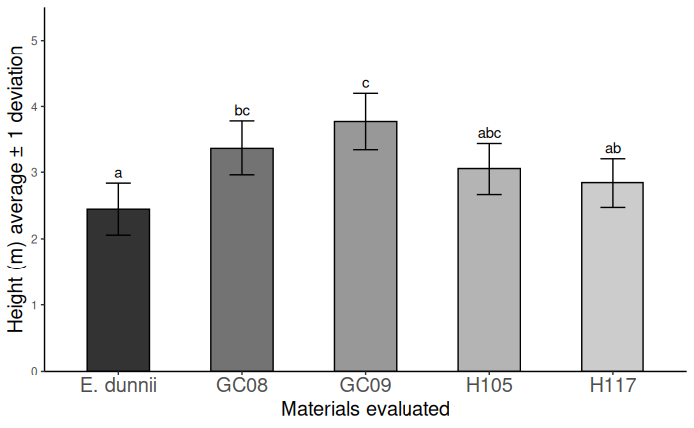

Figure 1: Average heights (m) of the materials evaluated and scale of the LSD Test (α =10%), similar letter: no significant differences are detected

Figura 1: Alturas promedio (m) de los materiales evaluados y escala del Test de LSD ([α](https://es.wiktionary.org/wiki/%CE%B1) =10%), *similiar letra: no se detectan diferencias significativas*

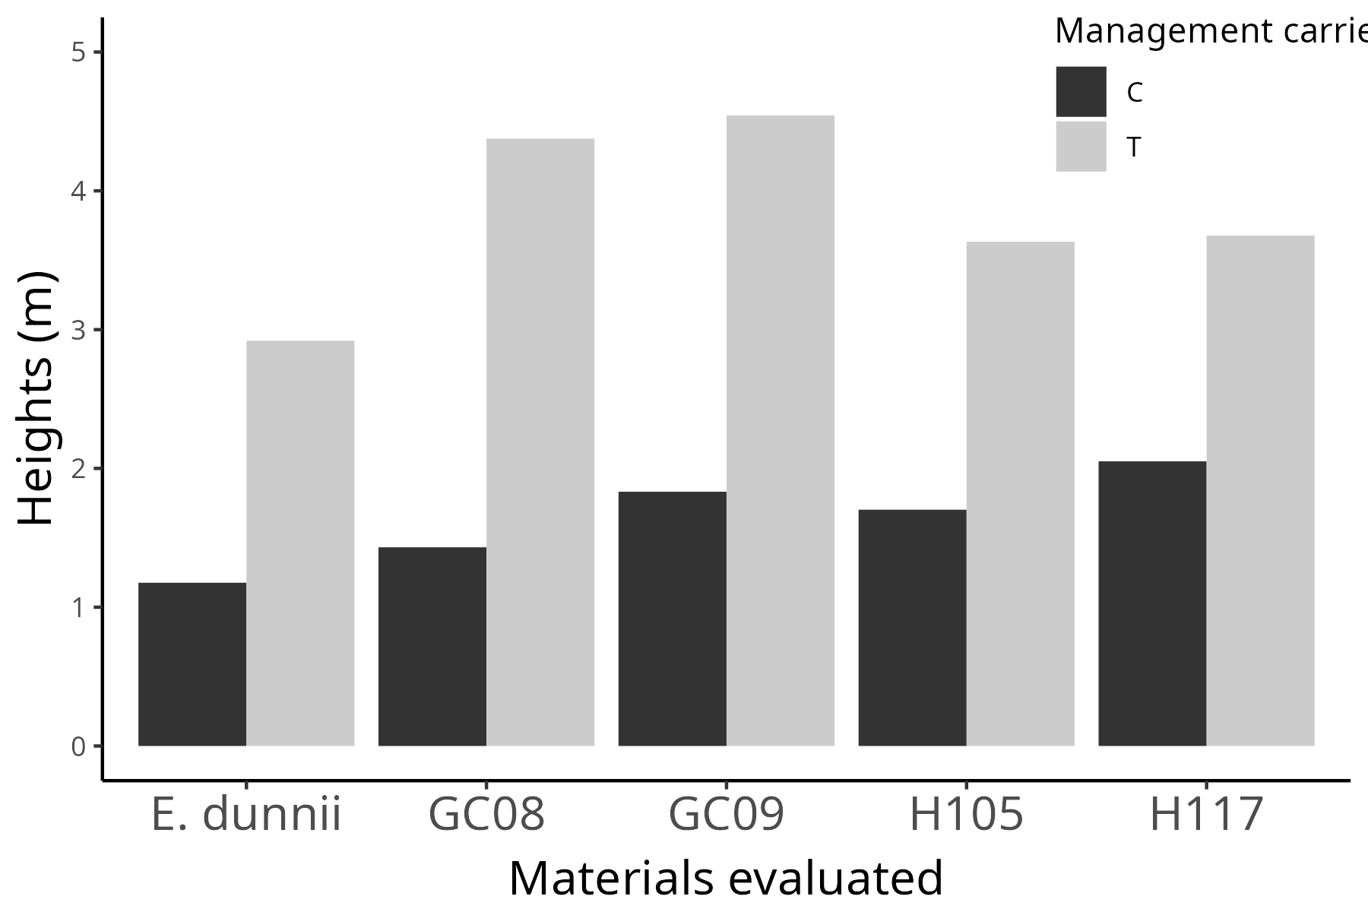

Figure 2: Average heights according to handling carried out and materials evaluated

Figura 2: Alturas promedio según manejo realizado y materiales evaluados

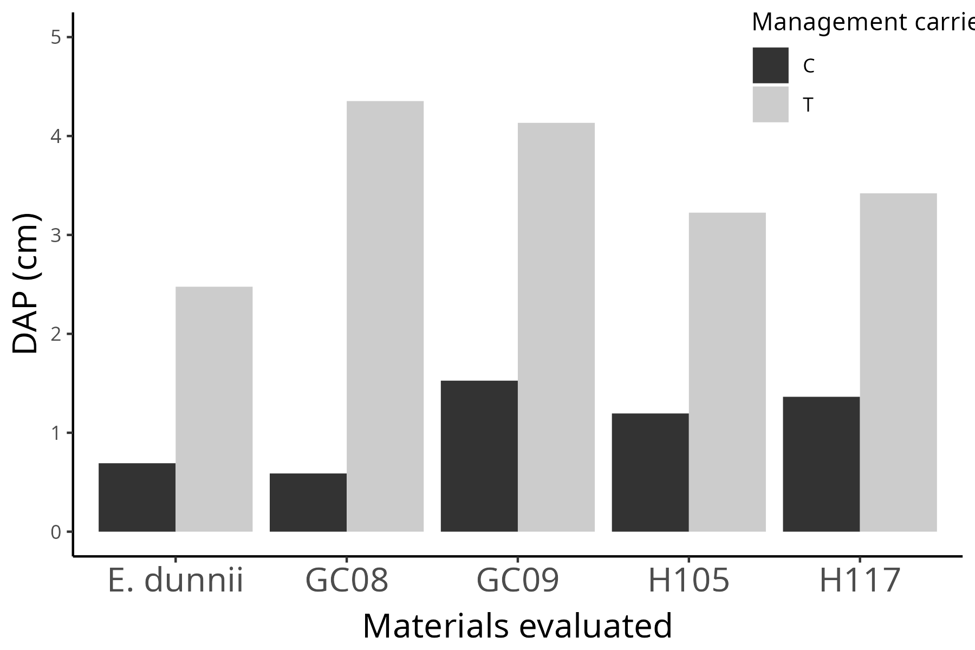

Figure 3: Average DAP according to management carried out and materials evaluated

Figura 3: DAP promedio según manejo realizado y materiales evaluado

In Table 2, the results of the contrasts to compare genetic materials are shown, including the best clone with the seed material, the average response of the clones with the seed material, and between GC clones (GC08 and GC09 with GCH105 and GTH117) for the height variable.

Table 2: Estimation of the contrasts and statistical significance (p value).

Tabla 2: Estimación de los contrastes y significancia estadística (p value).

| Contrast | Estimation | p value |
| --- | --- | --- |
| The best clone (GC08) vs seed (E. dunnii) | 0,926 | 0,052* |
| Average response of clones vs seed | 0,815 | 0,029* |
| Clones GC vs H | 1,248 | 0,064* |

In this research, lower plant loss percentages were observed in the clonal materials (GC08, GC09, GCH105, and GTH117) compared to the non-clonal (E. dunnii). Subsoiling of the soil increased plant survival in halomorphic soils.

The clones of hybrids GC08 and GC09 showed the best initial growth rates, along with lower percentages of plant losses. Clone GCH105 exhibited lower growth than clones GC08 and GC09, while clone GTH117 had the lowest initial growth rate. López et al. (2009) also observed differences in relation to the variables studied based on the eucalyptus materials used.

The lowest initial growth rates compared to clonal materials were obtained in the E. dunnii seed material, an alternative species to E. grandis due to its greater frost tolerance, productive versatility, and greater pest tolerance.

It was observed that, in the flood-prone areas without drainage present in the plantation lines, clonal materials reduced their growth compared to areas with drainage. This reduced the average of the analyzed variables but maintained growth superior to that of seeds.

Regarding plantation lines subjected to forest subsoiling treatment, significant differences were observed in all evaluated genetic materials, with higher growth rates in plantation lines with management and lower percentages of plant losses. Positive effects of subsoiling were also observed by Currie et al. (2004) and Ibañez et al. (2004). In this work, the effect of subsoiling under conditions of high soil compaction and density is highlighted, which possibly facilitated the rooting and initial development of seedlings and also allowed better water infiltration into the soil.

Meskimen and Francis (1990) reported that, on good sites, the height growth of Eucalyptus grandis can average 3.5 m annually during the first 4 years. In this research, conducted on halomorphic soils, good results were obtained regarding initial height growth in the first year of implantation in all clonal materials with subsoiling and base fertilization management since they presented values ​​higher than those mentioned in the work of Meskimen & Francis (1990). In cases where there was no management, the evaluated genetic materials presented values ​​lower than those previously indicated.

In the estimation of the contrasts for comparisons of the height variable, it was verified that the best clone, GC08, had a significantly greater response than the seed material E. dunnii. There were significant differences in comparing the response of the seed material versus the average from clone materials, in favor of the latter.

The great capacity demonstrated by the evaluated clonal materials, particularly GC08, to adapt to marginal soils and low agronomic aptitudes, which have higher productivity, frost tolerance, wood density, and less splitting in boards, as well as their wood being suitable for poles, sawing, and structural uses (González and Moglia, 2017, Paulforestal, 2017; Cuello, 2019), justified a recommendation in the subsequent economic-financial evaluation of this work.

**Economic and Financial Evaluation**

Based on the previously obtained results, an economic and financial evaluation was conducted for a design implemented with the practice of subsoiling on a 5-hectare plot with a planting density of 1.111 plants per hectare (spacing of 3 m x 3 m). The system involved clear-cut harvesting at 7 years, with the wood intended for sale as bioenergy.

For this purpose, investments, expenses, and revenues were projected, which are described

***Investments***

The purchase of the 1,111 seedlings was considered at a value of 0.26 USD each, totaling 289 USD per hectare. Additionally, the investment included implementation expenses (ant control, land preparation, planting, starter fertilization, post-planting irrigation) amounting to 742 USD/ha.

***Projected Expenses***

Expenses correspond to the costs involved in maintaining the plantation:

* 1st year: 304 USD/ha (irrigation, ant control, and weed control)
* 2nd and 3rd year: 264 USD/ha (ant control and weed control)
* 4th to 6th year: 24 USD/ha (weed control only in firebreak, covering 10% of the area)

***Projected Revenues***

The expected wood yield for the selected clone (GC08), considering losses of 15% in plants/ha, is 218 tons/ha, based on an annual growth of 65 m3/ha/year for the study area (Gorla, 2023), and a material density of 504 kg/m3 (Zechin, 2018; González and Moglia, 2017, Paulforestal, 2017; Cuello, 2019). According to qualified informants working in the study area, the value of wood for bioenergy is 40 USD/ton.

***Non-Repayable Financial Support (AENR)***

According to projected silvicultural treatment values for Santa Fe (Central Region), species: Eucalyptus, with a density of plants/ha of 950 or more, up to 20 hectares (Ministry of Agriculture, Livestock, and Fisheries, 2022), the percentage of non-repayable financial support for planting corresponds to 70%, 824.53 USD/ha.

***Cash Flow and Sensitivity Analysis***

Below is the cash flow of the forestry project and the results of the evaluation and sensitivity analysis (Table 3).

Table 3: Cash flow

Tabla 3: Flujo de fondos

|  | **Years** | | | | | | | |
| --- | --- | --- | --- | --- | --- | --- | --- | --- |
|  | 0 | 1 | 2 | 3 | 4 | 5 | 6 | 7 |
| ***Investments*** (USD) | 5.153 |  |  |  |  |  |  |  |
| Projected Revenues (USD) | 0 | 4.123 | 0 | 0 | 0 | 0 | 0 | 48.575 |
| Projected Expenses (USD) | 0 | 1.520 | 1.322 | 1.202 | 120 | 120 | 120 | 0 |
| Cash Flow (USD) | -5.153 | 2.603 | -1.322 | -1.202 | -120 | -120 | -120 | 48.575 |
|  |  | Cut-off rate | | 8,00% |  |  |  |  |
|  |  |  | NPV | 23.267 | USD |  |  |  |
|  |  |  | IRR | 41% |  |  |  |  |

As shown in the table, the results demonstrate the investment's convenience and the project's feasibility for the analyzed case. The project is considered feasible since the NPV result was positive (and significantly higher than the initial investment), and the IRR exceeded the discount rate by 80%, indicating a relative project safety. In this particular case, as it involves a cooperative, the impact of income tax on cash flow was not considered. If the evaluation had been conducted for a private project, the balance (cash flow) for year 7 would have been 37,666 USD/ha, NPV would have been 16,901 USD, and the IRR would have been 35% (still acceptable for the project).

The sensitivity analysis suggests that the project remains viable even with decreases in total income (due to various reasons such as lower wood yield for bioenergy or lower product value) of up to 89%. This means that the project can withstand a significant decrease in income.

The economic and financial results align with findings by other authors (Castro, 2014; Chávez, 2004) who evaluated Eucalyptus sp. forest plantation projects, and they also correspond with evaluations conducted in the Central region of Argentina (Jaime, 2003).

**Conclusions**

Regarding the technical aspects related to the forest project, it was observed in the field that the flooded areas in the planting lines of the clonal materials reduced their growth, thus lowering the average of variables analyzed in the trial. However, they still showed growth averages higher than those of seedlings. Concerning the planting lines subjected to forest subsoil treatment, significant differences were observed in all evaluated genetic materials, with higher growth rates in the managed planting lines and lower percentages of losses. Soil management with subsoil treatment in the planting line, when similar characteristics to those of this trial are present, is crucial to achieve better growth rates in planted trees, as well as greater plant survival, in any of the evaluated genetic materials and for both measured variables (height and DBH).

The different genetic materials and forest management practices used influenced the initial growth of the plantation (height). As for the DBH variable, more significant results are expected between genetic materials in future years.

The remarkable adaptability of clonal materials to marginal soils with low agronomic suitability is highlighted, allowing the utilization of currently unproductive soils or the management practices conducted on them not being in line with their potential use. This contributes to soil preservation, maximizes the potential of different regions of the country, and creates new bio-business models, diversifying activities. The evaluation of the developed experiment will continue in the coming years.

The results obtained demonstrate that forest cultivation with these materials can be a productive alternative in soils with the described characteristics. It is concluded that the proposed forest bio-business model is economically and financially viable.

The importance of circular economy in the productive processes integrated into diversification of activities is highlighted, along with the social and environmental value provided by forest inclusion. It also promotes the use and generation of renewable energy sources, further encouraging greenhouse gas mitigation due to the excellent carbon capture rate of the evaluated species.

It is recommended, therefore, to engage in forest production with fast-growing species to meet the growing market demand for forest products in the region, generating new jobs and income sources for the producer, in this case for the Cooperative, with excellent profitability.

The projection was made with the purpose of selling wood for bioenergy, which is the lowest expected destination compared to other higher-value selling opportunities, such as for sawmills. In future work, these other possible economic purposes will be analyzed.

**References**

AfoA. 2012. Bosques en Argentina. Bosques de Cultivo. <http://afoa.org.ar/bosques_en_argentina_detalle.php?p=41> (Accessed february 2023)

Araujo Vieira de Souza, J. & Bender, A. 2020. Libro Institucional UNL - Sistemas Productivos: Sistemas Agropecuarios Sostenibles. Sección 3. Capítulo 14. UNL.

Argentina Forestal. 2023. Precios de referencia de productos forestales del NE de Entre Ríos correspondiente a marzo 2023. Argentina Forestal. <https://www.argentinaforestal.com/2023/03/13/inta-concordia-precios-de-referencia-de-productos-forestales-del-ne-de-entre-rios-correspondiente-a-marzo-2023/> (Accessed abril 2023)

Banco de la Nación Argentina. 2023. Banco de la Nación Argentina. <https://www.bna.com.ar/Personas>

Braier, G. 2020. Estudio de tendencias y perspectivas del sector forestal en América Latina al año 2020. <https://www.fao.org/3/j1901s/j1901s08.htm>. (Accessed june 2023)

Candiotti, M. 2014. Santa Fe hacia una provincia maderera. Abordaje del Sistema Foresto industrial provincial. Producción Forestal. <http://forestoindustria.magyp.gob.ar/archivos/revista-produccion-forestal/11.pdf>. (Accessed february 2023)

Castro, E. J. (2014). Evaluación de un proyecto de inversión forestal, para el abastecimiento de una planta de cogeneración energética en el Dpto. Calamuchita [Universidad Nacional de Córdoba]. <https://rdu.unc.edu.ar/bitstream/> . (Accessed february 2023)

Chávez, A. (2004). Evaluación financiera de un proyecto de producción de madera de Eucalipto en la Provincia de Tungurahua [ESCUELA SUPERIOR POLITÉCNICA DE CHIMBORAZO]. <http://dspace.espoch.edu.ec/bitstream/123456789/4094/1/20t00260.pdf>. (Accessed junio 2023)

Congreso de la Nación. 2021. Ley 27.630. Ley de impuesto a las ganancias. <https://www.boletinoficial.gob.ar/detalleAviso/primera/245673> (Accessed junio 2023)

CRAN. 2022. Package ‘nlme’: Linear and Nonlinear Mixed Effects Models (R package version 3.1-157) [R]. R Core Team. [https://CRAN.R-project.org/package=nlme](https://cran.r-project.org/package=nlme)

Cuello, E. M. 2019. Estudio de la diversidad de insectos asociados a las plagas principales de Eucalyptus spp., para la selección de potenciales agentes de control biológico. (Tesis doctoral en Ciencias Biológicas), Universidad Nacional de Buenos Aires. 132p (30-35; 46-47; 55-56). <https://ri.conicet.gov.ar/bitstream/handle/11336/79763/CONICET_Digital_Nro.4cf17a7b-4f93-4dbc-9bb9-86e0299057f6_A.pdf?sequence=2&isAllowed=y>. (Accessed junio 2023)

Currie, H. M., Rujana, M. R. & Vásquez, L. B. 2004. Influencia del subsolado en suelos forestales de la provincia de Corrientes.

Damodaran, A. 2022. Damodaran On-line Home Page. <http://www.damodaran.com/>. (Accessed junio 2023)

Diouf, J. 2015. Agricultura mundial: hacia los años 2015/2030. <https://www.fao.org/3/y3557s/y3557s03.htm#c>. (Accessed may 2023)

González, D. & Moglia, J. 2017. Evaluación de propiedades relacionadas a la calidad de madera en Eucalyptus camaldulensis. Los Bosques actuales del Chaco semiárido argentino. Ecoanatomía y biodiversidad. Una mirada propositiva p.249-266. Facultad de Ciencias Forestales, Universidad Nacional de Santiago del Estero. <https://fcf.unse.edu.ar/archivos/publicaciones/libro-ecoanatomia/ecoanatomia-p3-04-gonzalez-Evaluacion-de-propiedades-relacionadas-a-la-calidad-de-madera-en-Eucalyptus-camaldulensis.pdf>. (Accessed junio 2022)

Gorla, Santiago. 2023. Prácticas agronómicas en el cultivo de eucaliptos en la región central de Santa Fe. Práctica profesional Agronómica, FCA-UNL.

Ibañez, C., Nuñez, P., Pezzutti, R. & Rodriguez, F. 2004. Efectos de la roturación del suelo y fertilización con fósforo en el crecimiento inicial de plantaciones de Pinus taeda, en suelos rojos del Noreste de la provincia de Corrientes, Argentina. Bosque (Valdivia), 25(2), 69-76. <https://doi.org/10.4067/S0717-92002004000200007>. (Accessed junio 2023)

IICA. 2019. Programa de Bioeconomía y Desarrollo Productivo. <http://repositorio.iica.int/handle/11324/7909>. (Accessed abril 2023)

Jaime, S. 2003. Costos de producción y análisis financiero para eucaliptos en el Nordeste de Entre Ríos. INTA. <https://aulavirtual.agro.unlp.edu.ar/>. (Accessed abril 2023)

Lopez, J. A., Genes, P. Y., Hernandez, J. A. L. (h. ), Pabla Yolanda GENES, Mariano, Marco, M. A., Harrand, L. & Oberschelp, J. 2009. Propiedades físicas, mecánicas y organolépticas de 10 clones de eucalyptus grandis de 1ra generación del programa de mejoramiento genético del INTA. INTA, 28.

MAGyP. 2020. Estadística- Granos - Carnes. <https://www.magyp.gob.ar/sitio/areas/gestion/> (Accessed abril 2023)

Meskimen, G. & Francis, J. 1990. Eucalyptus grandis Hill ex Maiden Eucalipto rosado. <https://www.doc-developpement-durable.org/file/Culture/Arbres-Bois-de-Rapport-Reforestation/FICHES_ARBRES/Eucalyptus%20grandis/Eucalyptusgrandis.pdf>. (Accessed junio 2023)

Ministerio de Hacienda. Presidencia de la Nación. 2019. Informes de cadena de valor. Forestal, papel y muebles. Año 4-No 14. <https://www.argentina.gob.ar> (Accessed abril 2023)

Misirlian, E. 2019. Análisis del complejo foresto industrial maderero en Argentina. 40.

ILO. (2019). Transición a la formalidad en la economía rural informal en América Latina y el Caribe: Políticas de mercado de trabajo y de desarrollo productivo. FORLAC Rural. [Proyecto]. <https://www.ilo.org/> (Accessed julio 2023)

Olavarría, J., Jara, C. & Troncosso, J. 2010. Formulación y evaluación de proyectos de inversión agropecuarios. Tópico VI. Universidad de Talca.

PACN. 2020. Carbono | Programa Argentino de Carbono Neutro. <https://carbononeutro.com.ar/> (Accessed abril 2023)

Paulforestal. 2017. Huerto Semillero Clonal 1.5 CIEF-Paul Forestal. <https://www.paulforestal.com/huerto> (Accessed mayo 2023)

R Core Team. 2023. R: A language and environment for statistical computing. R Foundation for Statistical Computing. [https://www.R-project.org/](https://www.r-project.org/)

Sapag Chain, N., Sapag Puelma, J. M. & Sapag Chain, R. 2014. Preparación y evaluación de proyectos. Mc Graw Hill Education. México.

Secretario de Agricultura, Ganadería y Pesca. 2022. Resolución apoyo económico no reintegrable. República Argentina - Poder Ejecutivo Nacional. <https://www.magyp.gob.ar/> (Accessed 10 abril 2023)

Zechin, M. 2018. Evaluación del crecimiento y adaptabilidad de materiales de eucaliptos con fines energéticos y maderables en el centro norte de la provincia de Santa Fe. Práctica Profesional Agronómica. Facultad de Ciencias Agrarias. Universidad Nacional del Litoral, 39 p.